Chapter 9, Problem 52.

If V_{o} = 8∠30° V in the circuit of Fig. 9.59, find I_{s}.

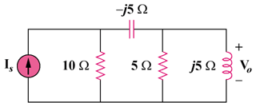

Figure 9.59
For Prob. 9.52.

